**SQL Assignment – 1**

**Create the below table named store_sales.**

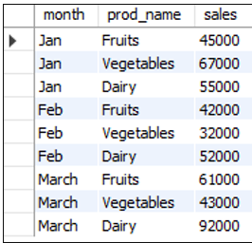  
  
  
  
CREATE TABLE `stores_sales`.`stores.sales` (

`MONTH` INT NOT NULL,

`PROD_NAME` VARCHAR(45) NOT NULL,

`SALES` INT NOT NULL);  
  
  
INSERT INTO `stores_sales`.`stores_sales` (`MONTH`, `PROD_NAME`, `SALES`) VALUES ('JAN', 'FRUITS', '45000');

INSERT INTO `stores_sales`.`stores_sales` (`MONTH`, `PROD_NAME`, `SALES`) VALUES ('JAN', 'VEGETABLES', '67000');

INSERT INTO `stores_sales`.`stores_sales` (`MONTH`, `PROD_NAME`, `SALES`) VALUES ('JAN', 'DIARY', '55000');

INSERT INTO `stores_sales`.`stores_sales` (`MONTH`, `PROD_NAME`, `SALES`) VALUES ('FEB', 'FRUITS', '42000');

INSERT INTO `stores_sales`.`stores_sales` (`MONTH`, `PROD_NAME`, `SALES`) VALUES ('FEB', 'VEGETABLE', '32000');

INSERT INTO `stores_sales`.`stores_sales` (`MONTH`, `PROD_NAME`, `SALES`) VALUES ('FEB', 'DIARY', '5200');

INSERT INTO `stores_sales`.`stores_sales` (`MONTH`, `PROD_NAME`, `SALES`) VALUES ('MARCH', 'FRUITS', '61000');

INSERT INTO `stores_sales`.`stores_sales` (`MONTH`, `PROD_NAME`, `SALES`) VALUES ('MARCH', 'VEGETABLES', '43000');

INSERT INTO `stores_sales`.`stores_sales` (`MONTH`, `PROD_NAME`, `SALES`) VALUES ('MARCH', 'DIARY', '92000');